Piedmont Progressive
Preschool
2021-22
Parent Handbook

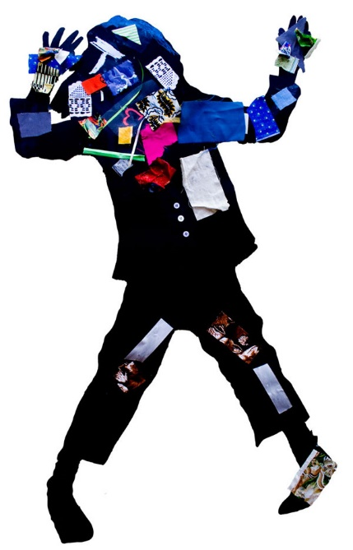

Contact Information
Director: Michele Deese
Address: 9704 Mallard Creek Road
Charlotte, NC 28262

School: 704-510-1022
Web: www.progressivepreschool.org
Email: progresssive.preschool@gmail.com

Class Schedules
2/3’s Thursday & Friday 9:00am – 12:00pm
3/4’s Monday – Wednesday 9:15am – 1:00pm
4/5’s Monday – Thursday 9:15am – 1:15pm

Emergency Closing Policy
Unless you are notified by the school, we will close with the Charlotte Mecklenburg School system for inclement weather.

Table of Contents

History and Founders 1
Council 2
The Philosophy of PPP 3
The Benefits of Ease In 5
Talking About Children in Their Presence 6
Helping that Hinders 7
Why Red Paint? 8
Holidays and Holy Days 9
Centers 9
Attending Piedmont Progressive Preschool 13
Appropriate Attire 13
Things from Home 13
Diapering Procedure 13
School Closings/Emergencies 13
Lunch 14
Transportation & Traffic Safety 15
Late Pick-Up Policy 16
Traditions 17
Health Care Policies 18
Financial Arrangements / Tuition Policy 19
Grievance Procedure 20
Evaluations 20
Classroom Management Policy 20
Inclusion Policy 21
Suggestions for Separating 22
Doing Your Part at Piedmont Progressive Preschool 23
Volunteering 24
Parents in the Classroom 25
Woodworking 26
Parent Education Events 27
Conferences and Meetings 27
Open Door School 27
“Little Boy” 28

Piedmont Progressive Preschool

History and Founders
In 2001, Mary Coppola and Susan Burns met at an open preschool in South Charlotte where their children were students. It was a long drive, and the two of them talked together about a dream for a similar preschool closer to home. They decided to start a non-profit progressive preschool in the University area. They based the school on the philosophy developed by Sue Riley, a highly respected early-childhood educator in Charlotte, who offered her wisdom and guidance as the school got off the ground. The vision for the preschool was that it be neither for-profit nor religious, and that it would promote freedom of thought and action for young children, and embrace a strong sense of visual aesthetics. Mary and Susan selected the Piedmont Unitarian Universalist Church because of its convenient location, wooded grounds, attractive classrooms, and reasonable rent (Susan being on the PUUC Board at the time). The preschool is separate and independent from the church, but close in spirit. The doors opened on October 16, 2001 with one multi-age classroom of three-to-five year olds. In January of 2003, a two-year-old class was added, and then in the school’s third year the four/five-year old class was inaugurated, with great success.
With each passing year the challenges have grown but the spirit of the preschool is strengthened as new teachers are hired who add their valuable experience to the program, and families who come to the school realize that it is a unique place in the University Area. Nowhere else is there a non-profit, non-sectarian school where the children are encouraged to be creative, free-thinking, independent individuals.
In 2005, Mary and Susan turned the school over to the parents in order to spend more time with their own children who had all aged out of the program. The parents decided that they would all pull together to help preserve this vital part of the community and ensure it would be available for future children. Sharon King stepped up to become the director/chair of our newly formed parent council and worked closely with other parents to continue the work of Mary and Susan. In 2012 Michele Deese, PPP lead teacher for 11 years, stepped into the role of director. The teachers, director and parents on the council have put their hearts, extensive experience and deep knowledge into continuing the tradition of allowing children to develop their minds and bodies at their individual pace. This nurturing environment, respectful of each child’s individuality, is unique among preschool programs.
Be the change you want to see in the world — Mahatma Gandhi
Play is Powerful — the PPP
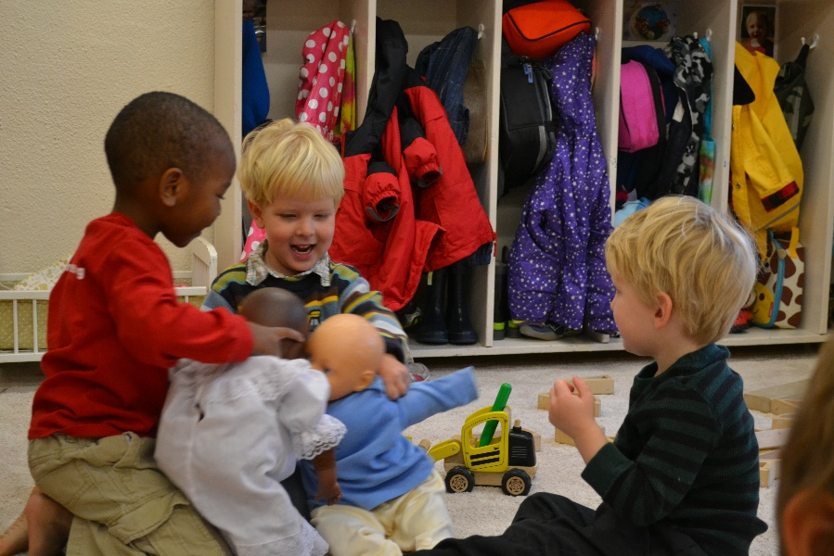

Piedmont Progressive Preschool Council

The Piedmont Progressive Preschool is a non-profit organization, governed by a Council according to our by-laws. This Council meets monthly. An email is sent out each month with meeting details. Everyone is welcome to come and encouraged to participate.
The Piedmont Progressive Council, made up of eight (8) voting members and many non-voting members, assumes general responsibility for the operations of the school.
The positions are:
*Co-Chairs: Mariya Narodny and Molly Troutman
*Secretary: Justin Handy
*Fundraising Chair: Cristina Frost
*Family Volunteer Representative: Rachel Deese
*Newsletter Editor: Rachel Deese
*Receiving Treasurer: Frances Loren
*Disbursing Treasurer: Chris Kelly
*Advertising Co-Chair: (open)
Parent Representative (2/3’s class)
Parent Representative (3/4’s class) Stephanie Klein
Parent Representative (4/5’s class) (open)
Website: Molly Troutman
Librarian:
Photographer: Kacie Steele
Yearbook: Katiria Rodriguez
Gardening Chair:
Building and Grounds Chair: (Open)
Susan Burns, Founder of PPP

* voting members
Accountant, Dennis Tax Service

The Philosophy of Piedmont Progressive Preschool

Learning from decision making: to make the complex and numerous
decisions required of them as adults, children must begin when they
are very young to believe that they are capable of deciding.
PPP’s philosophy is based on discovery learning—the belief that learning, growing, and developing are natural, intuitive, and inevitable processes. Children want to learn, be independent, and competent. They are naturally curious, innovative and creative. Thus, teachers should function as facilitators, protecting children’s natural curiosity and encouraging investigation and inquisitiveness, thereby enabling children to develop according to their own potential. Growth cannot be compartmentalized. PPP nurtures each child’s strengths and weaknesses at each stage of development and maturity.
Throughout its history the school has embraced racial, cultural, religious and economic diversity and has included special needs children in order to provide an environment in which children may learn to understand and accept each other. PPP strives to guard the dignity of each individual so that children feel free to explore, question, experiment and play. PPP encourages children to work on resolving conflicts peacefully, to cooperate rather than compete, and to accept and honor the differences among us.
What We Teach
Piedmont Progressive developed its own rich curriculum to include music, art, science, blocks, books and literature, dramatic play, outdoor play, stitchery, cooking and woodworking. The goal of the curriculum is to give children the skills they need to be competent learners:
- A positive self image
- Problem solving
- Resourcefulness
- Self-reliance
- Observation
- Flexibility
- Adaptability
- Tolerance
- Cooperation versus competition
- Self-direction and self-motivation
- Ability to resolve conflicts peacefully
- Ability to analyze and generalize, associate and differentiate, and integrate

How We Teach
Piedmont Progressive believes that education is a lifelong process, and that growth cannot be compartmentalized. Here at Piedmont Progressive, we encourage discovery learning through hands-on activities, open-ended situations, and play. There is more information on this topic in the section on centers, page 9.

Curriculum
The educational philosophy of Piedmont Progressive was formulated using the research of many great educators, including Jean Piaget, Maria Montessori, Constance Kamii, Bev Bos, and Erik Erikson. Piedmont Progressive Preschool’s unique curriculum is detailed in Sue Riley’s Pathways to Learning, which includes descriptions of centers, woodworking, and gardening curricula. In order to create a developmentally appropriate curriculum teachers will:
- Integrate all areas of a child’s development (physical, emotional, social, and cognitive)
- Observe and record each child’s special interests and developmental progress
- Post the curriculum and any changes in activities in the classroom
- Prepare the environment so that children learn through active exploration and interaction with adults, other children, and materials
- Utilize learning materials that are concrete and relevant to young children’s lives
- Make a reasonable effort to meet the needs of children who exhibit unusual interests and skills outside the normal developmental range
- Provide a variety of activities and materials
- Present materials sequentially, increasing the difficulty and complexity of an activity as the involved children develop their understanding and skills
- Engage children with materials and activities by asking open-ended questions or making suggestions that stimulate their thinking
- Facilitate a child’s successful task completion by providing support, focused attention, physical proximity, and verbal encouragement
- Recognize that children learn from trial and error and that children’s misconceptions reflect their developing thoughts
- Provide multi-cultural and non-sexist experiences, materials, and equipment
- Provide a balance of quiet and active time (both indoors and outdoors), and self-directed (“free choice”) and guided activities

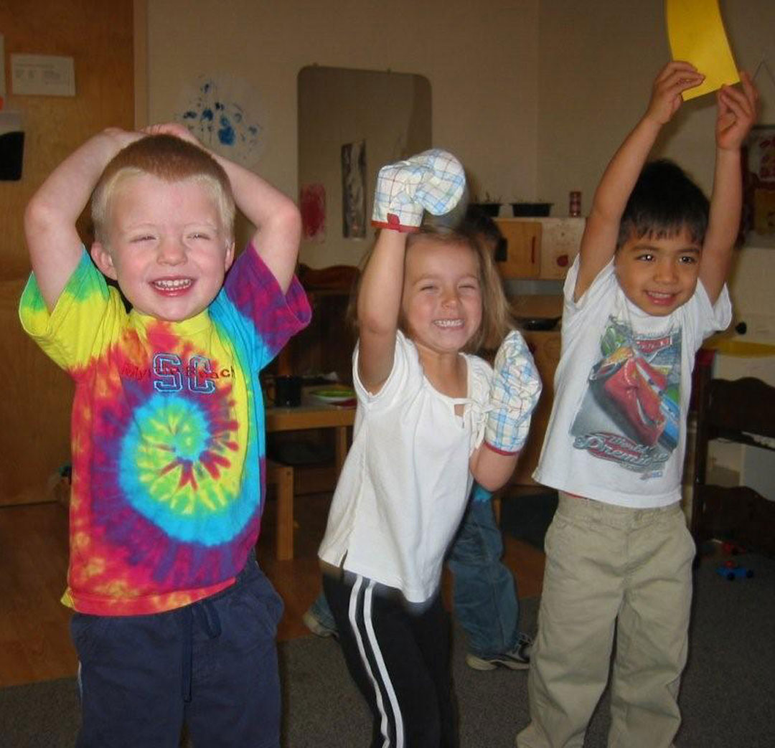
The Benefits to Ease-In
What is “Ease-In”? Why does it take so long? These are two questions parents often ask at the beginning of each year. This is an attempt to help you understand the importance of Ease-In and the benefits it provides to your child and the classroom.
Have you ever worked in a job that threw you right into the regular routine without giving you the opportunity to figure out with whom you were working, a tour of the facility where you worked, and an orientation to give you expectations and schedules? It can be a bit overwhelming for us as adults. Now imagine a child two, three, or four years of age jumping feet first into a new situation. At school, the children come to a new environment, encounter new and interesting tools for learning, meet and interact with new adults and lots of new children, and are asked to conform to a new routine.
Now, multiply that one situation times 16 and you have a class of 4s and 5s at Piedmont Progressive!
Our goal is to make this transition into school as smooth and gentle as possible. Of course, children develop at different rates, and some may be able to handle coming to school all day on Day One. The reason for Ease-In is not based solely on the individual child, but rather on the class as a whole. The ideal situation is that, together, the children and teachers experience the routine a little bit at a time, adding on as the routine becomes familiar and the month progresses. This has been successful in helping children learn all the transitions they have to face each day at school without being overwhelmed and stressed by the big picture (the whole day).
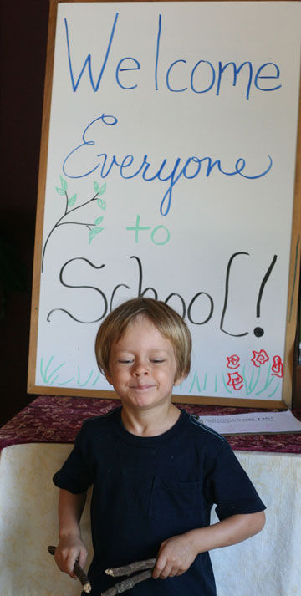
It is sometimes hard to remember that time and simplicity are gifts. We are caught up in this fast-paced society, which expects that we go until we can’t go any more, and then we collapse or break down and cry. At Piedmont Progressive, we prefer the gentle, slow and steady pace of the Turtle to the hurried and frenzied pace of the Hare.
So, as we move through Ease-In each fall, remember that we have the best interest of your child, as well as the whole class, at heart.

Talking About Children
One aspect of our philosophy is that we try never to talk about children in their presence. We feel that it is disrespectful to the child to behave as if they are not present while discussing them. If you would like to discuss issues about your child, please feel free to email or call a teacher, ask her to call you, or choose a moment when your child is otherwise engaged. Here is an article that might shed light on this subject:

TALKING ABOUT CHILDREN IN THEIR PRESENCE
By Katherine Reeves
We all talk about children in their presence. In our thoughtlessness, we all have at some time done it – before we had our eyes opened to its cruelty and discourtesy. We have all undoubtedly been the victims of it, as children. And the memory of our discomfort and embarrassment should have been enough to deter us from its practice forever.
But strangely, when we become adult in years, we often forget what it was like to be a child. We forget how keenly children feel, how insufficient their understanding of the ways of grownups is, what it is like to be small and defenseless and to have to stand miserably by while your shortcomings are discussed.
Why do grownups talk about children in their presence? Do we really think children have no ears, no comprehension of words, no sensitivity to glances, and no ability to catch implications from adult talk? And what kind of example in manners, in courtesy to others, is communicated to a child who must listen in while he is being discussed?
Such conversation gives sanction to two kinds of behavior (which adults often at great pains try to teach children not to indulge in) – namely, gossiping about other people and eavesdropping on adult conversation.
We must believe that this is simply thoughtlessness and not intent. But it is well to think of its meaning to everyone.
We would not suggest, of course, that adults should not talk together about children – their own and other people’s. This is part of adult responsibility, especially that of parents and teachers who share in the guidance and teaching of children. But we do suggest that much of what is said about children in their presence borders on gossip and is destructive to morale. Often the adult uses the device of talking about a child’s problems and difficulties in an effort to teach a lesson obliquely. And the child knows this. He readily gets the slant of the conversation and discovers that it is directed to him, although his actual physical presence is ignored.
One of the great needs of the child, and one which does not diminish greatly with age, is the need to feel that not only is he accepted by the important people in his world – and all grownups are important in a child’s world – but also that he is respected. A child doesn’t have the words to label the relationship that accords him respect for what he is and what he tries to do. But he has the feeling. And when this feeling is violated, as it must be when he must stand by and know that he is the subject of secretive conversation (or of conversation that is not at all secretive but that is disregarding his presence), he loses a little of his faith in the grown-up world.

Helping That Hinders
Our classroom has a steady, hummy feel to it in the mornings. Your children enter, greet friends and teachers and dig into the work of childhood—exploration! We adults are excited to see children learning as they play, and most of us want to join in, perhaps in fond remembrance of our own early days. We are often quite eager to share with them what we know.
However, there is a fine line between imparting helpful information and interfering with the child’s exploration of materials. Some adults may think it’s fun and educational to demonstrate play dough techniques such as worm rolling and snowman crafting; or, a grown-up might want to show a child how to do a really nifty drawing with crayons; one might also conclude that when an adult demonstrates the art of bridging in the block corner it would be useful for a preschooler.
Unfortunately, adult modeling (showing how) robs a child of the chance to discover creativity on her own, in her own good time. It really doesn’t teach these skills. Modeling does train a child to wait, to follow directions, to follow someone else rather than think one’s own ideas.
Most of us are aware of the scribble stage that children go through with art. They actually need time to “scribble” with sand, blocks, and other materials as well. A young child playing with blocks for the first time will probably enjoy piling them and moving them around the room. The child is getting a sense of the blocks’ weight and feel. Later comes stacking and placing side by side. There are decisions to be made here. With enough opportunity to really experience the blocks, the children will discover on their own that by placing a block lengthwise across two other blocks they have built a bridge. What joy! What a great satisfaction!
A well-meaning adult may build a structure with blocks that pleases the child. But what frustration the child may feel as she tries to reproduce it! The child has been robbed, for the block building has become something to watch, not do.
Children who are given the chance to explore materials freely grow up to be creative thinkers, problem solvers. Their creativity is not stifled because they do not stumble over the thought, “What am I supposed to do with this? I don’t have any ideas.” Creative children work to please themselves, not to please someone else. They grow up to be our thinkers, our doers.
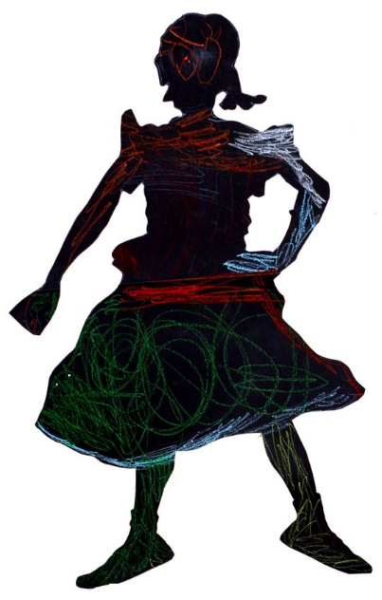
Of course we still want to join in their play, and we can if we follow their lead. Poke the play dough, sift the sand, but don’t call the shots.

Why Red Paint?
A parent of a two-year-old said to us one autumn day, “You sure are hung up on red paint, aren’t you?” It was good that she said that, because it brought to mind our reasons for what we are doing, and gave us an opportunity to communicate our thinking with you. Yes, it is true that so far every time we have had paint, it has been red, and will continue to be red for a long time. Very young children have had little opportunity to experience painting, and we want them to explore the process of applying paint to the paper without being distracted by making choices about which color to use. We see the amazement in their eyes as they take the brush, dip it into the paint, and actually make red appear on the paper. Some have learned already that the use of paint is soon followed by the very popular washing of hands. They are learning that an adult will put their name on the paper, and that they can take the wet painted picture to the hall to dry. They have learned to make strokes with the brush, or to dip with a sponge or another object. They are beginning to learn the difference between painting on paper and painting on the table. They are learning to sponge off the table, floor, and hands when they, too, become red. This is a lot for them, and for now, it is enough. Other colors will come along as the children mature. Right now, they are simply into painting for painting’s sake. Learning is a process, not a product. Please feel free to ask about this or anything else; it’s good to make us think.
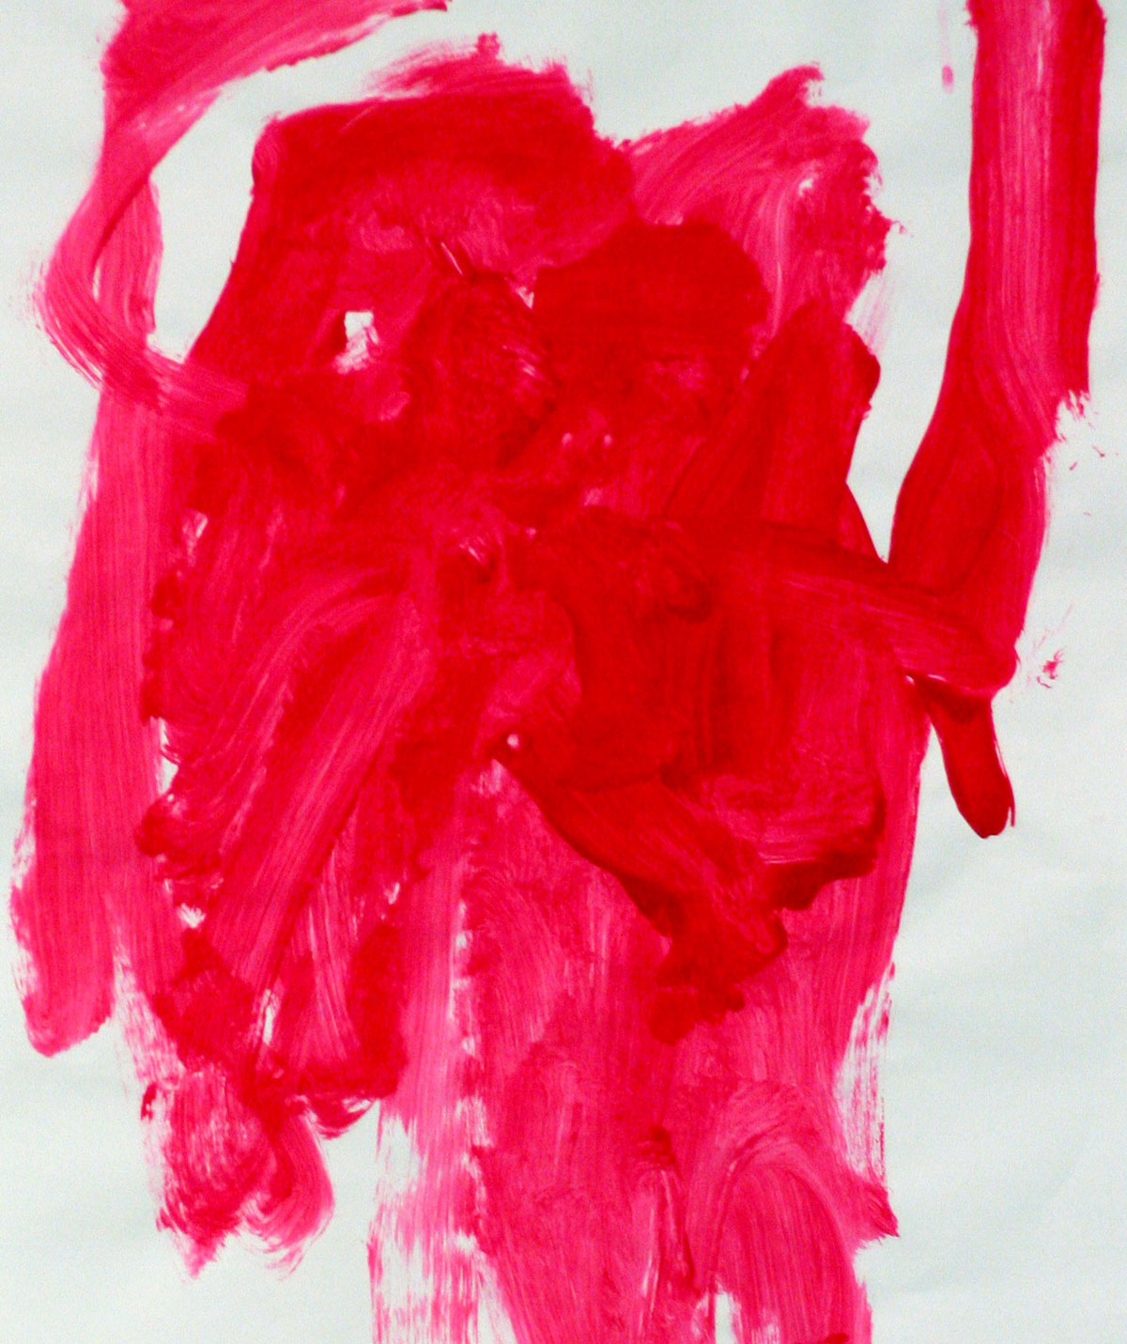

Holidays and Holy Days
We believe that holidays are best celebrated within the context of family, homes and places of worship where they can be honored with the respect they so richly deserve. Our classrooms are places where children of all beliefs, cultures, and traditions come together to grow and learn while experiencing traditions common to all (i.e. “The Candle Song” at lunchtime). In a society where holidays are surrounded by commercialism, we strive to make PPP be a respite for children (and adults!) from a frantic world that overwhelms us all.
We are a place where children are encouraged to express themselves using an array of colors and materials rather than colors and decorations dictated by the traditions of each holiday. We are a place where children can sing, tell stories, dress up, build blocks, and cook without being confined to songs, stories, and recipes of the “season.” Remember that caring and nurturing adults will listen to stories that your children tell and the conversations they have about their own traditions and celebrations. What we can do well in this setting is listen well and warmly to what children share, and share that back with you.

Centers
Art
Art is a means of expression and a path to individuality. The artistic process is an important creative outlet for children. Image-making helps children process life experiences and fantasies. It heightens their aesthetic awareness and sensitivity to beauty. The artistic process generates many opportunities for problem solving; creative, critical, and, especially, intuitive thinking; and developing decision-making skills. Manipulative, pre-writing, reading, and social skills are enhanced as children code and decode the world around them through their creations. Art is a matter of seeing—both literally and intuitively. It aids in cultivating senses. It is also is pleasurable and satisfying. It gives children opportunities to say something about themselves, by themselves, through unique marks on paper.
Piedmont Progressive teachers…
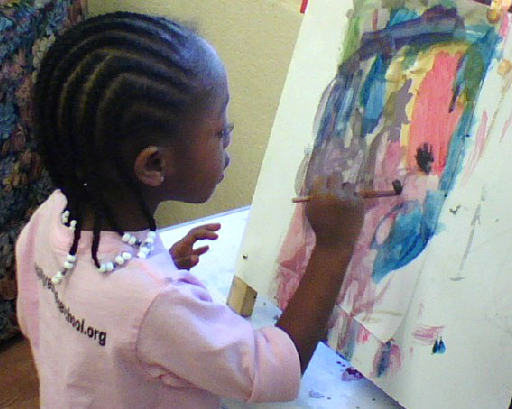
- Give no pre-direction, modeling or expectation to children in terms of finished product or use of materials
- Respect the right of children to discard what they have made
- Recognize and accept age and child appropriate skills
- Change plans at the children's suggestions
- Observe children carefully and strive to identify and meet their needs, and let children go about their discoveries in peace

Blocks
Almost all aspects of a child's development can be enhanced through the use of blocks. Because blocks are designed in mathematical units, they aid in the development of concrete understanding of concepts essential to logical thinking. Awareness of sizes, shapes, numbers, order, area, length and weight develops as the children select, build with and put away blocks. The child’s physical development of both large and small muscles is enhanced. Language, aesthetic, and social development grow, along with problem solving skills, cooperation, and respect for others and their work.
Books
Books are the traditional backbone of learning. In addition to the many materials now available to children of all ages, books remain integral to the learning process. Today's offerings in books have grown in range and expertise. The primary goal at Piedmont Progressive is to teach the children to develop a love of books and a love of reading them, the wealth of vocabulary building, and the evolution of communication skills. Through exposure to books and reading, the children learn to foster creativity and imagination. Books reinforce the recognition of cause and effect and sequencing of sentences and events. At Piedmont Progressive we hope to excite as many senses as possible to stimulate holistic growth.
Dramatic Play
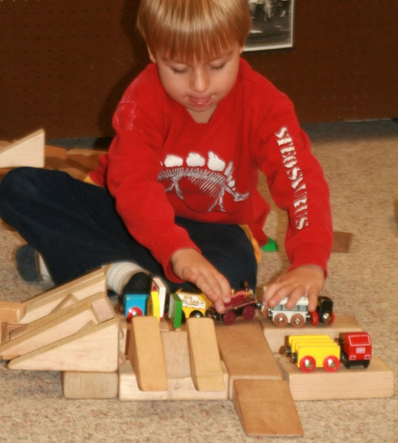
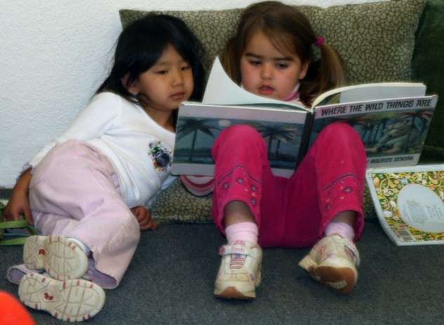
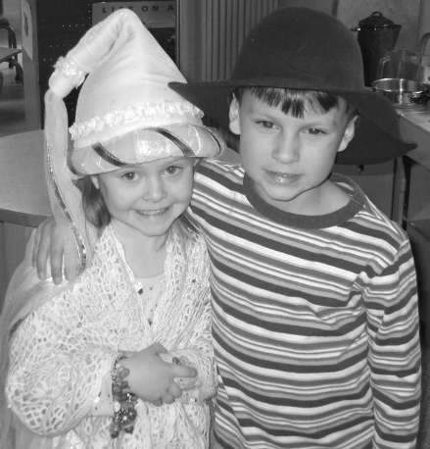
In dramatic play, children take their real experiences with people and things, combine them with their thoughts and feelings about those experiences, and come up with new ideas. They can then use these ideas to create new experiences, which in turn produce more ideas—and so on it goes.
A wonderful creative outlet, role-playing allows children to try out new ideas in a safe environment, work out emotions, and share experiences. It promotes interaction with peers, and aids in the development of vocabulary and social skills.
Manipulatives
Manipulatives not only promote versatility and creativity, but also provide opportunities for learning in several areas at once, including math, physics, spatial relations, verbal and social growth, problem solving, decision making, small and large muscle coordination, aesthetics and imagination.
Music & Movement
Music and rhythmic movement are a natural part of all cultures, which is why we include it in so many aspects of our classrooms. Our objective is to provide opportunities for children to have fun with music, and to experience rhythm, mood, and melody in a relaxed and joyful atmosphere. While music is a creative, social, emotional, physical, and cognitive outlet, above all it is fun! Music in the classroom encompasses singing, listening, instrument use, and creative movement. It allows children to express their moods, assimilate information, and develop language.
Music is used in the Piedmont Progressive classroom to…
- Transition from one activity to another, i.e. from group time to the lunch table;
- Focus the attention of a group of children;
- Rest our bodies;
- Practice sound, rhythm, patterns, numbers and language;
- Be a living participant in the oral traditions of our culture;
- Inspire and to be enjoyed!
Outdoor Play
The major difference between indoor and outdoor play is the opportunity of more space, more freedom, more movement, more noise, and different construction materials—especially sand and dirt. The outdoors is a place where adults and children can make music, cook and eat, enjoy stories and make them come to life, play with water, work with tools, care for dolls and dress up, and create with paint, or with clay and other natural materials. Much of children’s social development takes place on the playground as children learn to take turns, form groups for play, etc. We believe outdoor play is a vital part of a child’s development as this will provide the opportunity for them to explore outside each day in all kinds of weather (unless it is really nasty outside). It is important for children to dress appropriately for the weather and expect your children to be quite dirty at the end of each school day.
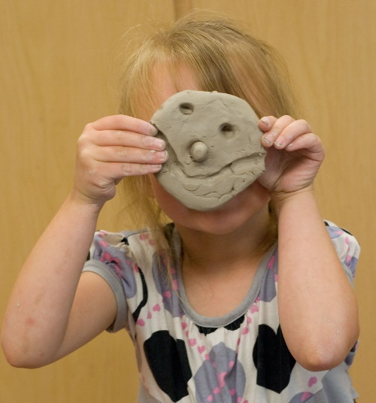
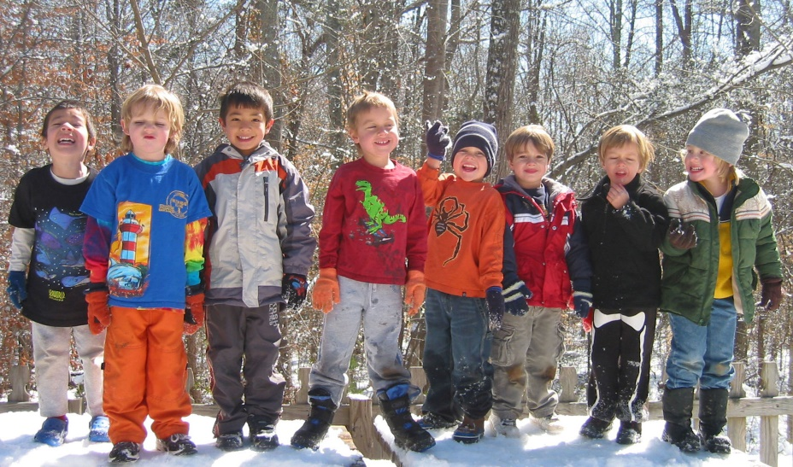

Play Dough & Clay
Play dough and clay are basic raw materials included in a quality preschool program. They are forms of three-dimensional art that are easily used by children of various ages. Play dough is soft and made from a flour and salt base whereas clay is derived from raw earthen material and is stiffer. Both materials are easy to manipulate and appealing to the sense of touch. Clay is especially appealing to the need to be "messy" because of its damp feel. Pounding, smashing, and pulling apart clay and play dough can allow children to vent intense emotions.
Sand & Water
Sand and water are naturally soothing substances. Children have a powerful desire to explore these media, which provides them with both sensory stimulation and opportunities for scientific discovery. They develop cognitive and observation skills while determining how the addition of water to sand changes its weight, texture and cohesive properties, and also while determining why certain objects sink in water and others float. As with many of the centers, children play together at the sand and water tables, building friendships and developing social skills.
Woodworking
Woodworking uses such a variety of skills, tools, and materials that the opportunity for unstructured conceptual learning is almost unlimited. Mathematics and basic laws of physics are part of measuring, fitting, balancing, and use of force. Practice in coordination is constant. Decision making and planning are a large part of the experience. The children are free to learn on their own while assisted by a parent volunteer.

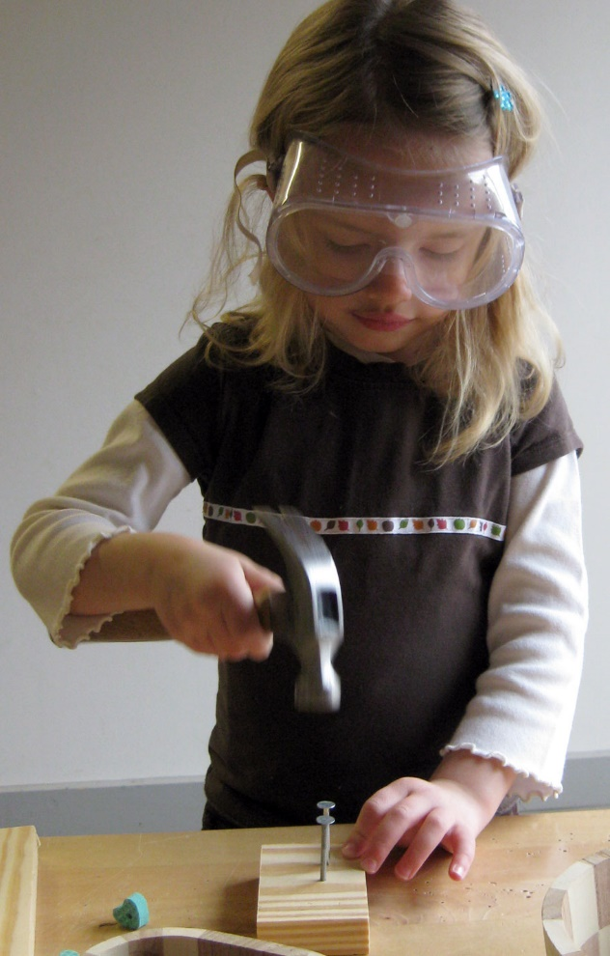
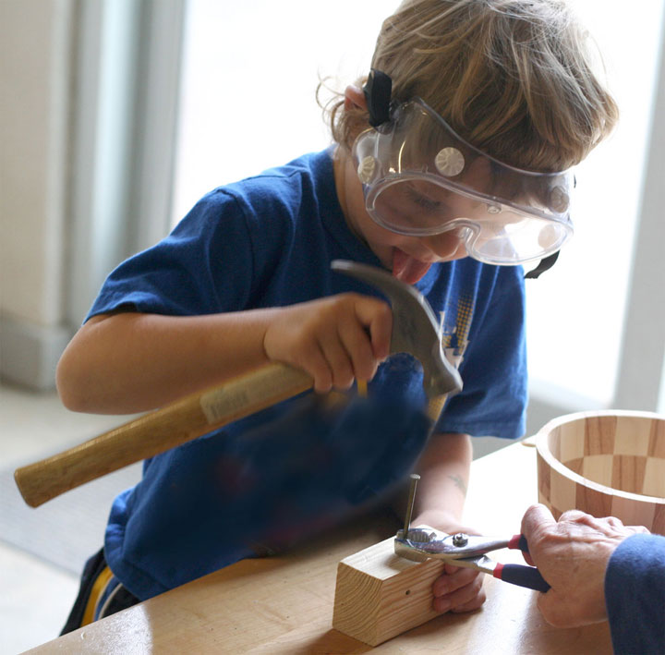
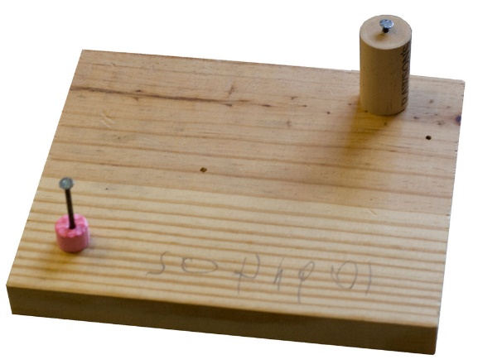

Attending Piedmont Progressive Preschool

Appropriate Attire
Please dress your child for active play. This means casual, WASHABLE clothes and sturdy, soft-soled shoes. Tennis shoes are perfect! In order to prevent as many injuries as possible, we do not allow flip-flops, cowboy boots, or other slick soled shoes. Also, be sure that your child’s clothing can be managed during toileting. We do go outside in drizzly and cold weather, so raincoats and boots are appropriate. (Please, NO UMBRELLAS!) Layers are especially useful in spring and fall, when the weather is much cooler in the morning and warms up quickly as the day goes on.
Remember that our art is all hands-on – children will come home with paint on their clothes. We will also be doing gardening and everyone will get quite dirty. Please do not send your child in “Sunday best” clothes.
Put your child’s name on all clothes, and be sure to send an extra change of clothing, including socks. Check the extra clothes in your child’s cubby and adjust appropriately as the weather changes throughout the seasons. Please, do not send backpacks. They are too bulky for our small cubbies.

Things from Home
Our resources/materials are carefully selected for the development of the child and for group play. We ask that toys from home not be brought to school. We have found that they set up a competitive situation. If you know your child has a real need for a “lovey,” please talk it over with his/her teacher.

Diapering Procedure
We believe that all children are individuals, and as such, deserve individual attention when it comes to diapers. Teachers will periodically check each child and change him/her on an individual basis as soon as they detect that the diaper needs to be changed, or if the child requests it. We certainly do not want a child to be uncomfortable. Teachers will not change a child if the diaper appears to be relatively dry. That way teachers and children can spend the majority of their time in the classroom or on the playground with the rest of the class.

School Closings/Emergencies
In the event of inclement weather, we follow the policy of Charlotte-Mecklenburg Schools (CMS). If CMS calls for a late opening, PPP will be closed (unless you hear otherwise). If there is an emergency and we need to close the school early, someone will call each parent or emergency contact to pick up the children, and the teachers will stay until the last child is picked up.

Lunch
When you pack your child’s lunch, please be mindful of your child’s health and of the earth. Pack food in reusable rather than disposable containers (i.e. no packages that end up in the trash). This helps foster independence in the children and allows us to send home any uneaten food, so you are aware of what your child eats. Plus, it’s good for the environment.

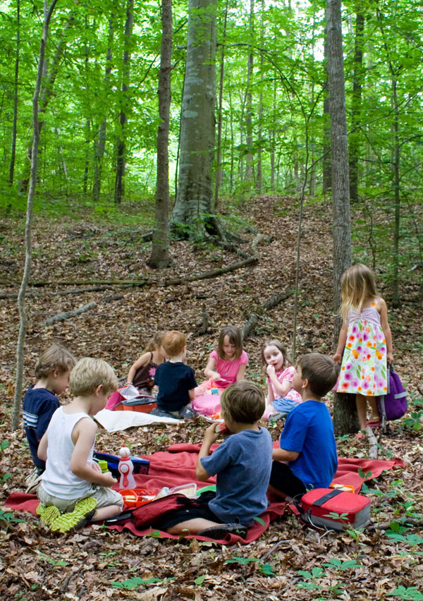
Please include a cloth napkin, any utensils necessary and a reusable water bottle. Please make sure your child’s name is on their lunch box and anything else that can be labeled.
Suggestions for Lunches:
Sandwiches
Deviled/boiled eggs
Cut up fruits and vegetables
Crackers
Oatmeal
Pretzels
Cut up cheese
Cooked Noodles
Cut up meat
Muffins
Raisins and dried fruits
Dry, whole-grain cereal

Please send just two or three favorite items in your child’s lunch box. Children generally eat better when they are not overwhelmed with too many choices.
Please do not send candy, cookies, etc.
Thank you for supporting our efforts in encouraging healthy lunches.

Zero Waste Lunches

Several years ago, beginning on Earth Day, PPP implemented a new challenge to all our families. We challenged our families to send “ZERO WASTE LUNCHES” to school.

As an environmentally conscience school, we hope to set an example for our children and teach them the important roll we all play in protecting our Earth.

Parents are encouraged to pack lunches with only reusable containers, cloth napkins and washable utensils. Reframing from using prepackaged foods such as lunchables and disposable drink containers will greatly reduce the waste that is added to the earth.

Transportation and Traffic Safety

There will be a teacher greeting and helping children out of the car from 9:15 to 9:30 am. No child should arrive prior to 9:15 am. The teachers are involved in important planning and preparation until then, and are not ready to give children their full attention. Please do not ask us to make exceptions. Drop-off and Pick-up begin after ease-in schedule. Also, for your child’s safety, the front doors will be locked daily at 10:00 am. If you are coming after that time, you must enter through the doors at the playground.
Please make your best effort to pick up your children on time each day. Try setting up a buddy system with several other parents who pick up at the same time so that you can call someone and ask for help with your child if an unavoidable circumstance prevents you from being on time. Getting to see the inside of a friend’s car can be a real treat as you wait in the parking lot for Mom to arrive. And a mini play date on the playground while Dad safely makes his way to school would help everyone feel less stressed. As a community we can all support each other, our teachers and our children by working together.
For the safety of all, we must load children into their cars as quickly as possible. The distance from Mallard Creek Road to our pickup area is approximately 6 or 7 car lengths. If people stop to visit with one another, or ask teachers questions, an arriving parent may not be able to enter the parking lot safely from Mallard Creek Road. Please pull into a parking space in the front lot and walk in if you would like to speak with a teacher or another parent.
If you would like to talk to the teacher about your child, pickup time is not the best time to do this. Please ask the teacher to call you, or set up a meeting at a mutually agreeable time, where the child will not be present.
All children must be safely strapped in child restraint seats. Children are safest in the back seat. Teachers will bring the children to the car and then you should buckle your child into his/her seat.
If you are picking up a child whose class is being dismissed from the playground, please park in the lower half of the parking lot. Children MUST be with an adult at all times in the parking lot. Please hold your child’s hand as you cross the parking lot to your car. If you would like to visit with another parent, please park and remember to NEVER leave your child/children in a car unattended.
If you are visiting your child’s classroom/playground and have other children with you, please do not ask teachers to watch them. The teachers’ first responsibility is the children in their care; they cannot supervise additional children.
We cannot accept verbal messages from children. Please write a note if your child is to go home with a friend or different driver.

***PLEASE RESPECT HANDICAPPED PARKING SPACES***

Late Pick-up Policy

It is important to your child and to the Piedmont Progressive Preschool staff that you pick your child up promptly at his dismissal time. Your predictable punctuality will ease anxiety and nurture trust and confidence in your child. Moreover, our teachers are expected to adhere to their after-class schedules and duties. Our staff and your child need your full cooperation and consideration.
However, in the event that you are late for your child's dismissal time, our Late Pick-up Policy is as follows:
First occurrence: A written warning notice will be issued.
Subsequent occurrences: Lateness fines will be charged at a rate of $15 for every 15 minutes late.
1-15 minutes late $15
16-30 minutes late $30 (And so forth)
The fine must be paid within 24 hours and should be left in the Tuition Box in the school office. An invoice will be issued in triplicate to include a copy for your child's file, a copy for your records, and one for the office manager, who will keep account for the school.
In the event of an emergency, please have a back-up plan in place and notify the PPP staff as necessary. Be sure to provide all emergency names and numbers on your Pick-up Authorization Form, which will be kept in the school office.

Traditions
The Candle Song:
Little candle burning bright,
Won’t you share with us your light?
May we always learn to share,
With other children everywhere.
The Candle Song is sung before lunch (snack in the 2/3’s class) to foster a sense of community.

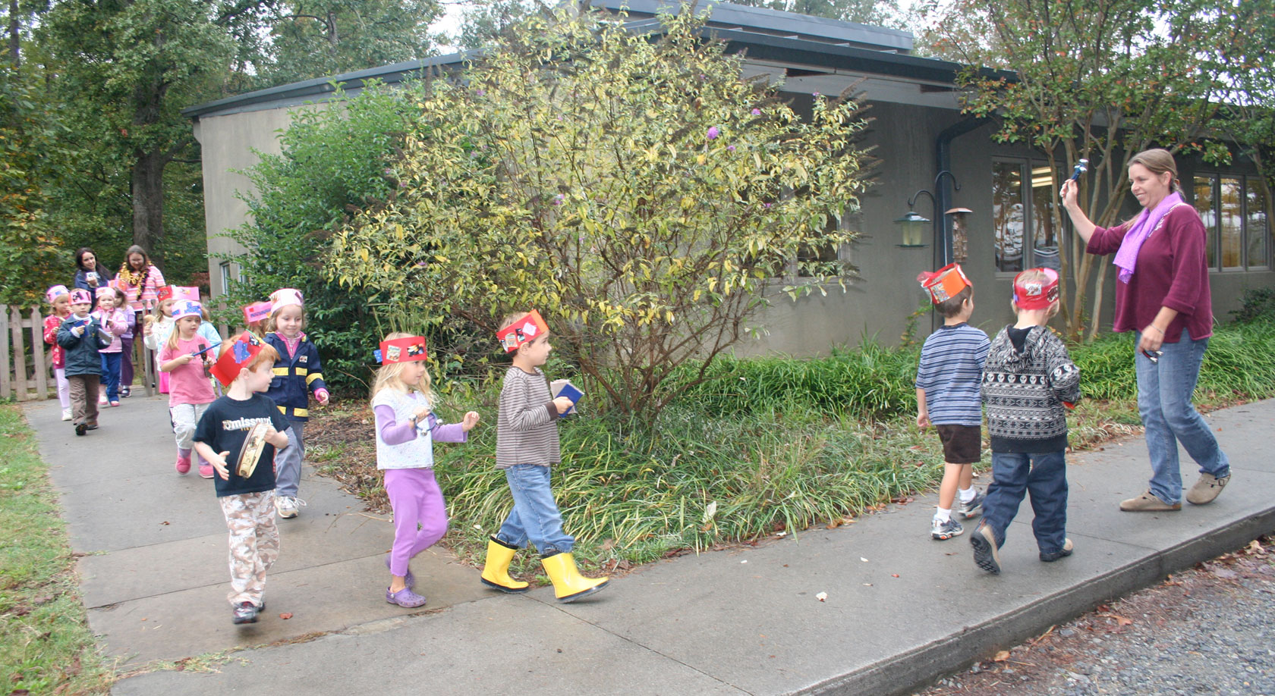
Founder’s Day Parade
Every fall, in mid-October, the school celebrates and honors our founders, Susan Burns and Mary Coppola. The 3/4’s and 4/5’s classes and teachers dress up and parade around the tree planted for their dedication.
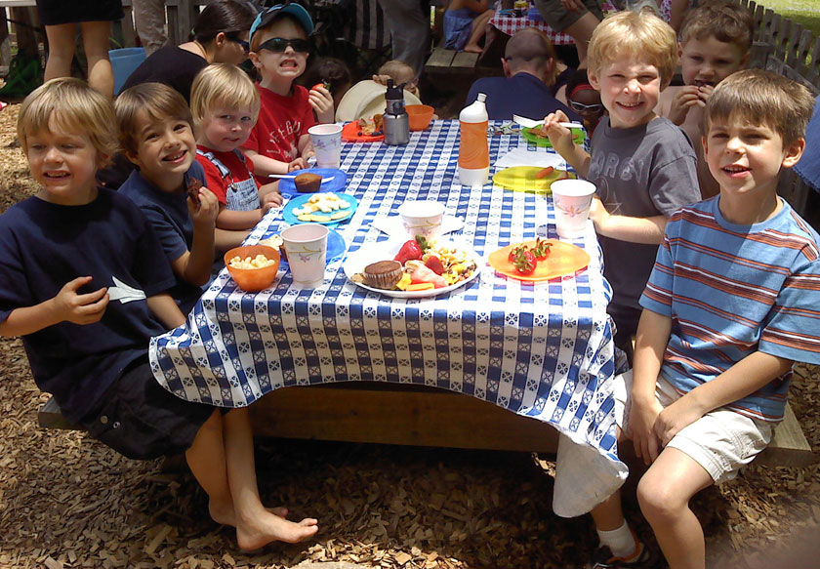
End of the Year Picnics
During the last week of school, your family will be invited to join your child’s class on the playground for a picnic lunch. Coming together is a wonderful way to finish out the year and welcome summer.

Health Care Policies
If your child has any of the following symptoms, you will be asked to pick up your child from school as soon as possible; both for the safety of your child, and to prevent the spread of illness. In the event that a parent cannot be reached, an emergency contact from your emergency card will be called. In case of contagious illness a doctor’s note will be required before your child can return to school. We understand that it is difficult for a parent to leave or miss work; therefore, it is suggested that if necessary you arrange a backup for children when they are sick.
If your child is sick or unable to come to school, please let us know - especially if your child is contagious. Feel free to call the school’s phone number (704-510-1022) in the morning. Leave a message on the voicemail if no one is available to answer. (Also, if you are taking a vacation, please let us know when we can expect your child’s return.)
CHILDREN WITH ANY OF THE FOLLOWING SYMPTOMS MUST REMAIN AT HOME UNTIL THEY HAVE BEEN SYMPTOM FREE WITHOUT FEVER-REDUCING MEDICINE FOR 24 HOURS:
- Temperature of 100 degrees or higher
- Vomiting
- Diarrhea or loose stools inconsistent with usual bowel movements
- Any suspicious rash
- Persistent colored nasal discharge
- Any contagious illness
- Any symptom requiring one-on-one care and/or causing severe discomfort
- Any open, oozing sore, bacterial infection and/or bloody gums
- Surgery (tubes, etc.) Your child cannot return to the school until 24 hours have passed since the time of surgery.
When returning to school after an illness, please remember the following:
- Your child must be free from all symptoms for 24 hours or longer
- Your child must be able to participate in all activities, including outside play
- Chicken Pox lesions must be completely dry and there should be no other symptoms present
- Children taking prescription medicine for a contagious illness must have taken it for at least 24 hours
- Any contagious illness (i.e. pinkeye) requires a doctor’s note to return.
Please do not ask your child’s teacher to administer medication of any kind to your child. If your child is in need of any medication, please administer the medication at home before school. Because your child is only here for a period of four hours at most, there should be no need to ask teachers to give your child medication. Please note that this also includes sunscreen and bug spray, because we cannot be responsible for each child’s reaction to these products.
Disclosure of Medical Conditions
Parents have both the right and the responsibility to share in decisions about their children’s care and education. For the safety of all children at Piedmont Progressive Preschool we ask that parents notify the director in writing on the emergency card and medical report regarding any special physical, emotional, or health concerns concerning their child, and that this information be provided to PPP prior to registration and enrollment. Special concerns include (but are not limited to) children with chronic medical conditions, physical disabilities, psychological illnesses, developmental disorders, or severe allergies). Piedmont Progressive Preschool strives to be open and accommodating to all children and their families; however, PPP reserves the right to assess a child’s condition and our reasonable ability to keep the child safe while respecting the rights of other children and families. Once enrolled, some children will require special consideration and an extra effort on the part of PPP staff, the child’s parents, and (in some cases) classmates’ parents in order to keep the special needs child safe and in order for the child to feel welcome and a part of the larger classroom.
Special Needs Children
When a child with special needs is initially enrolled, the director may request a meeting with the child’s family and teachers before the school year begins in order to discuss what information should be communicated to other children in the class and to their families. Although PPP recognizes the danger of stigmatizing special needs children (and, thus, the importance of keeping some information confidential), PPP also believes that sharing simple, accurate information about special needs children helps everyone involved be more caring and understanding. Hurtful stereotypes and discriminatory behavior usually arise out of ignorance. Sharing information openly in a non-judgmental manner sets a precedent for openness and a willingness to learn from others. Secrecy (even if ostensibly to protect a child) implies a shameful secret and sets a precedent for distrust and discord. Piedmont Progressive affirms sameness AND difference. Refusing to acknowledge special challenges certain children face is not only a lost learning opportunity, it forces all involved to pretend the differences do not exist.
Therefore, PPP will encourage families of special needs children to share as much information about their child as they can with the director and the child’s teachers. In some instances the director may also work with the family to prepare a letter to send to other parents in the special needs child’s class in order to explain the child’s condition and offer ways for other parents to answer questions their children may ask as they notice differences in the special needs child. This letter could share information about the different developmental milestones the special needs child may have and about what the child finds challenging and what the child does well. It may also be helpful to include how the special needs child feels about his condition and to emphasize how much the child is like any other child in the preschool class. References to other helpful books, articles or information for parents and children may also be useful as well as the director’s and family’s availability to answer further questions.

Financial Arrangements / Tuition Policy
Registration fees are payable when you apply for a child’s enrollment at Piedmont Progressive Preschool. No application will be considered if the registration fee is not paid. Fees are NOT refundable after a child is accepted and an enrollment slot is reserved. If a space is not available for your child, he will be placed on a waiting list and your registration fee will be refunded until a space is available at which time registration will be due upon acceptance of the space. Failure to remit registration fees within 5 days will result in forfeiting your child’s space.
TUITION PAYMENTS are due on the 1st of each month. (This applies during winter vacation and other times when we may not have school on the 1st of the month.) Please place your tuition check in the box marked "Tuition" in the hallway or you can mail it to the school at the following address: 9704 Mallard Creek Road, Charlotte NC 28262
Late Payments: If your check is later than the 5th of the month you must add a $10.00 late fee to your payment. Our school is a non-profit organization and relies on tuition in order to continue operations, so it is vital that you pay on time. If you have any financial concerns or questions, please contact Michele Deese.
Returned checks: A $30 fee will be assessed for any check returned for insufficient funds. This fee covers costs incurred by the school. If banking fees exceed $30, the family will be asked to pay the additional fees.
Tuition Deposits collected at registration are held for May’s tuition. Thus, no payment is due in May. There will be no refunds.

Grievance Procedure
If you have concerns or grievances in or about the classroom, please first address your child’s teachers. For any non-classroom issues, please first address the parties directly involved. The next step to resolve your grievances is to bring them to the attention of the director. If your concerns are not satisfactorily addressed, please notify the council in writing (you can drop this off at the school labeled “attn: council co-chairs) so that your concerns may be addressed by the school’s entire governing body, which will make the final decision.

Evaluations
At the end of every school year, PPP takes the opportunity to elicit feedback on our program, teachers, and director. Please look for these evaluations and complete them. The results are tabulated by the council chairperson and are reported in aggregate in order to maintain confidentiality. We would like to hear from you what is working and what is not. These evaluations are taken very seriously. We appreciate your input.

Classroom Management Policy
Discipline at our school will take the form of positive classroom management, which will:
- Recognize that children are unique individuals and behave and learn in different ways
- Strive to establish a warm atmosphere of cooperation and trust.
- Strive to help the child become self-controlled, that is, help him/her experience the intrinsic pleasure in appropriate behavior as opposed to “behaving” just to please adults.
- Encourage children to be independent and to solve their own problems. The teacher will offer assistance when needed and model along the way.
- Provide age and developmentally appropriate equipment, materials and activities.
- State expectations in the positive form, such as, “walk please” vs. “don’t run.”
- Speak to the behavior, not the child, such as, “Hitting hurts; let’s find another way to solve this problem” vs. “You’re a bad girl for hitting.”
- Respect the child and the child’s belongings, artwork, etc.
- Allow the child to experience the natural and logical consequences of his/her behavior whenever possible. For example: the natural consequence of playing too roughly with friends is that they may not want to play with you. The logical consequence of spilled milk is that you clean it up. A natural consequence requires no outside involvement. A logical consequence needs an adult to follow through.
- Allow the child acceptable means of expressing anger, frustration, sadness, hurt or fear—all of which are honest, healthy emotions. Crying, screaming or hitting a pillow are all acceptable outlets.
- If necessary, in order to prevent a child from hurting himself or others or from doing damage to equipment, a teacher will calmly but firmly hold a child to prevent such harm. The child will be held as lovingly as possible with a helpful attitude rather than a punishing or admonishing one.
- Use “time out” as a last resort after other management techniques have been tried. During this time, the child is placed in a chair or at a table, within sight of the teacher. The child may determine when he/she is ready to get up or a short (2-3 minute) time limit may be set. We do not refer to this as “time-out” to the child, but rather as some quiet time away from the group to sort out their feelings.
- Use no corporal (physical) punishment.
- Teachers will speak to parents whose child exhibits behaviors that are detrimental to dynamics in the classroom. Together the parents and the teachers will create strategies for improving the situation.

Inclusion Policy
At Piedmont Progressive Preschool, we believe that each child is unique, and can bring to our program valued qualities and skills. We also believe that most children can benefit from a social environment that includes people of many different backgrounds, abilities, and perspectives. Our environment and resources allow us to provide for the diverse needs of much of our community. In order to serve our community well, teachers and families may occasionally require professional consultation or special services from agencies outside PPP. We will support efforts to help our children be positively contributing members in the classroom. PPP is not a therapeutic setting, but a place for children to develop the broad range of skills necessary for forming lasting and meaningful relationships with other people and their environment. We realize, however, that we are not always successful in meeting the needs of every child.
If a child enters our program and at some point during the year it becomes evident that his needs are greater than what PPP can reasonably provide, we will take these steps:
- The child will be observed in the classroom setting by teachers, the director, and with permission from the parents, professionals from outside agencies;
- After observation, the director, parents, teachers, and/or other professionals will meet to discuss and develop a strategy determined to best meet the needs of the child;
- If a child’s needs are found to put an exceptional stress on the classroom, the parent will have the opportunity to hire a shadow to provide additional support;
- Once a developed strategy has been put in place, times to meet for periodic review are scheduled. Open and frequent communication among all involved parties is imperative during this time to make a child’s experience successful. Assessment will be based on input from parents, classroom teachers, the director, and special service professionals, as well as the behavior of the child while at school after sufficient time a determination is made about the child’s continued presence in the classroom.
There are three possible determinations at this time:
- The classroom is a suitable placement for the child;
- A recommendation for professional consultation or special services is made, with the expectation that temporary intervention will enable staff and children to develop skills necessary for the mutually beneficial relationship;
- Piedmont Progressive Preschool is unable to meet the child’s needs.

When the staff sees the necessity for professional consultation, but the parents decline to use offered services, the parents may be asked to seek placement for their child in another program. In rare instances, and after professional consultation, the school may determine that it is unable to meet a child’s needs. The director will notify the parents of the decision and offer assistance in finding a more suitable placement for their child.
At Piedmont Progressive, the safety and well being of the entire class must always have priority over the individual needs of any given child. We hope to accommodate as diverse a population as possible, in the belief that diversity strengthens and enriches all members of a community.

Suggestions for Separating
- Have lots of discussions with your child on his/her level about your leaving. Make sure that your child understands that you will not be staying with him/her at school. Reassure that you will always come back.
- If you are planning to immediately depart and are able to leave your child easily, please do so as soon as you can.
- Give them time words that they can understand. i.e.: “I will play one puzzle with you then I must go.” Or “I will be back at outside time.”
- Tell them you are leaving and say good-bye. (Sudden disappearances make children scared and mistrustful.)
- If you say you are leaving – leave. (Lingering, or coming back and forth, sends mixed messages to the child.)
- If you are unsure about leaving, you can always wait in the foyer or make sure that we have a number where we can reach you. We always call parents when a child is inconsolable.
- “Lovies” (security items) can sometimes ease the transition from home to school. Talk to the teacher if this is necessary.
- If you feel your child still needs you for moral support, please find a quiet corner, sit down and be as non-intrusive as possible. Please allow some space for your child to interact with others.

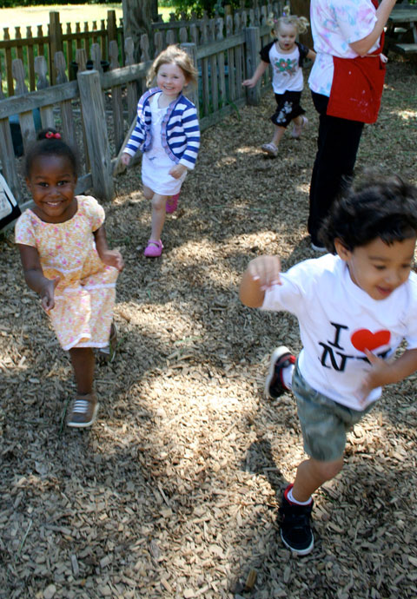
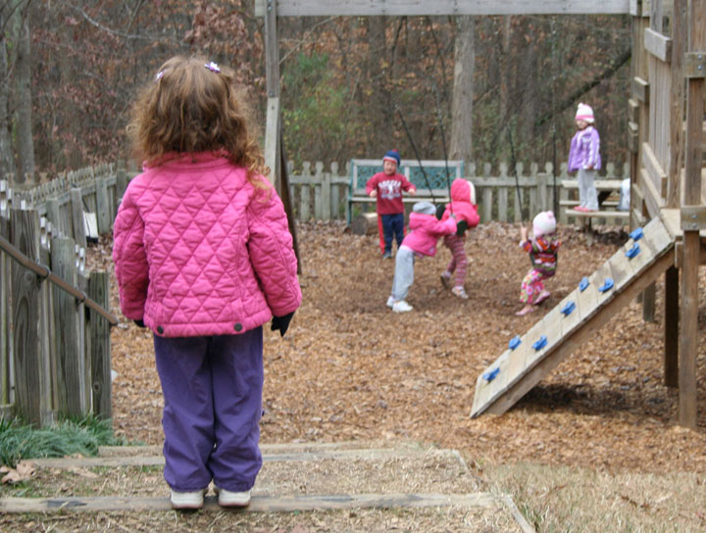
Doing Your Part at Piedmont Progressive Preschool

Volunteerism and the Piedmont Progressive Community
Piedmont Progressive Preschool is a nonprofit organization with no financial support from state or other government sources. Almost 100% of your tuition money goes toward our operating costs. We rely heavily on parent involvement and fundraising for all of the school’s other needs. Volunteerism is a vital part of our success!
We all have different reasons for coming to Piedmont Progressive and different future educational goals for our children. The one thing we all have in common is the desire for our children to enjoy themselves and have a positive preschool experience. By becoming involved with our school, your entire family benefits enormously. Children learn by imitating their parents. Volunteering expresses your enthusiasm for PPP, and your involvement demonstrates community spirit. Helping out at PPP is also a great way to get to know other parents and meet the people who make it the outstanding place it is.
Piedmont Progressive understands that not all parents have the time or skills they feel are necessary to contribute. Be assured, there is something for every level of expertise, interest, and commitment. Sometimes we just need folks with an opinion. If you still don’t feel you have enough time to volunteer, maybe you have a family member or close friend who could help out in your stead.
Piedmont Progressive volunteer activities are great fun. Please consider volunteering. You just might enjoy yourself!
We have a Parent Volunteer Coordinator, whom you can go to with a question or concern. We want you to feel “plugged in” and comfortable jumping right into our little community. If you have any questions or great ideas, please let any council member know.
We very much appreciate your cooperation and help!
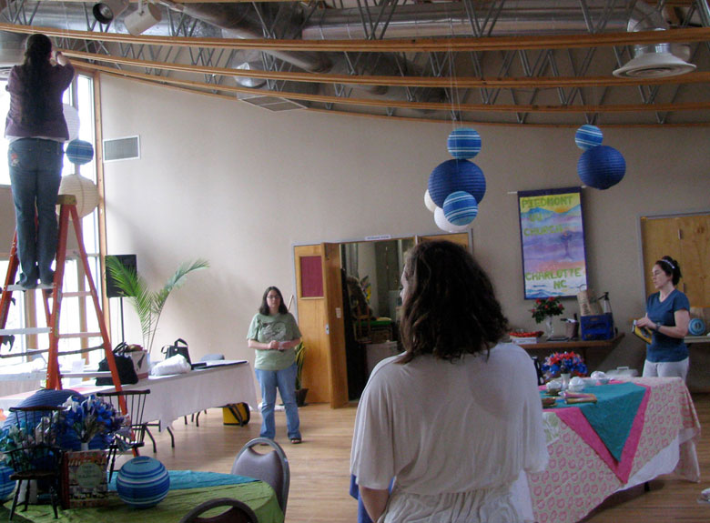
Volunteers setting up for the Seventh Annual PPP Silent Auction.

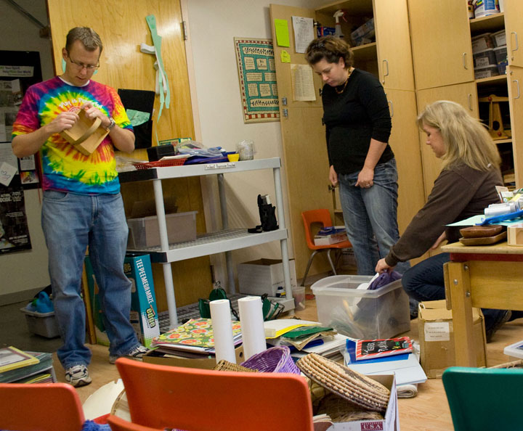
Guidelines for Parents Volunteering in the Classroom
Volunteers and PPP teacher clean the classrooms.

Please make arrangements for childcare for other children.
Wear comfortable clothes.
Your child may be very excited to have you in the classroom. They may be possessive of you or be more emotional than usual. This is perfectly normal and it is okay for you to give your child extra attention.
You can help by reading to the children, putting names on artwork, helping children wash and dry hands after art. In the 2/3’s class parents also help prepare and set up snack.
The teachers will handle changing all diapers, except your child’s.
Except for extenuating circumstances, teachers will handle all conflicts in the classroom, but would appreciate a third set of eyes and ears to alert us to any problems.
When talking to children, get down on their level and use low tones. Sit down, whenever possible. Try to avoid judgmental statements, like “I like that’ or “That’s good.” Instead comment on what they actually did. “I see you stacked the blocks very high.” Or “You drew a lot of lines on your paper.”
Allow the children to explore the materials in the room on their own. Instead of giving them ideas or showing them how to do something, ask them, “What can you do with that?”
On the playground, we do not pick up children and put them on the play equipment. The ability to get on the equipment by themselves indicates a readiness to be there. It also gives them a great sense of accomplishment to figure out how to do it on their own.
If you have a conflict, please arrange to switch days with another parent.
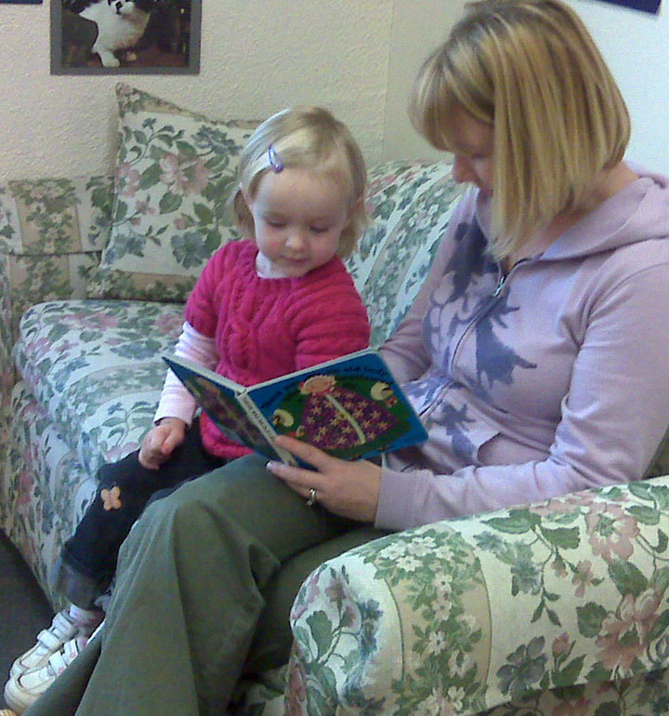
For the 2/3’s class, bring snack for the class (10 children and 3 adults). It works best to have two or three items to choose and NOT mix the items together. Snack should be fresh fruits and vegetables. (Apples, bananas, oranges, strawberries, berries, melons, kiwi, pineapple, carrots, corn, peas, green beans, broccoli, cauliflower, and green pepper are just a few suggestions.) We will provide water for the children to drink.
We hope you enjoy the days you assist in classroom. It can be a very educational and rewarding experience, but will also make a huge difference in making sure all the children’s needs are met in the classroom.

When Parents Observe in the Classroom
We appreciate parent volunteers in the classroom and welcome you to visit, generally at any time. However, too many adults can greatly affect the energy of our classroom and interfere with our ability as teachers to interact with and get to know the children. So we ask that you please follow these guidelines when you are in the classroom.
If you want to spend time in the classroom just observing, please find a quiet corner, sit down and be as non-intrusive as possible. Allow some space for your child to interact with others.
Please take conversations with other parents or with teachers to the hallway. It can be very disruptive to children when adults are chatting in “their” space.
Please remember that talking to a teacher while in the classroom takes her attention away from her main focus. If you have serious concerns, they need to be handled either by phone or conference. Ask the teacher to call you or set up a meeting.
All conflict resolution (discipline) needs to be handled by the teachers.
Listen to how the teachers speak to children and speak in the same manner (to your child, and/or to other children). This means using a calm, deliberate tone, speaking to them as equals and using positive, non-judgmental phrases.
When a child shows you a piece of artwork, think of something specific to say about it instead of “That’s beautiful!” “I like that!” or “Great job!” For instance, if you tell the child that you notice they used the color blue, or that they made zigzags instead of straight lines, that will show the child that you are really looking at what they created and not just passing judgment.

Woodworking
Starting in the spring, each week the 3/4’s and 4/5’s classes spend a morning doing woodworking. Parent volunteers are needed to man the woodworking station. Look for sign up sheets in the classrooms.
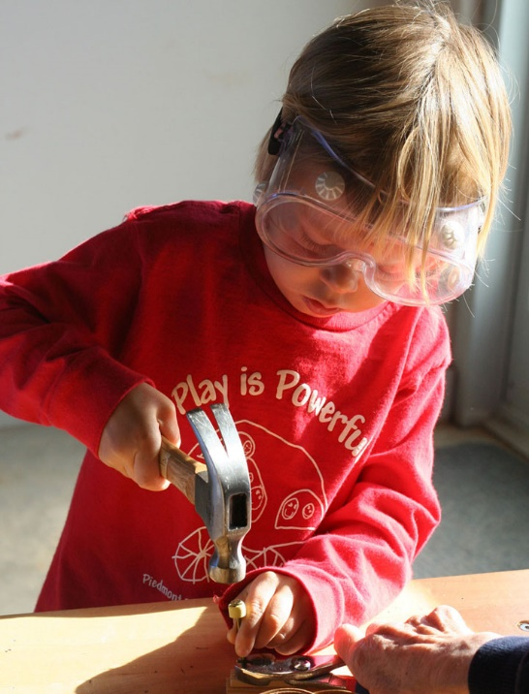
(Wood)Working with Children
Woodworking at Piedmont Progressive is about process, not product. Three-year-olds are curious about the tools and the materials and, most of all, enjoy making sawdust. Four-year-olds experiment with combining pieces, and, if their work reminds them of a boat or plane, they may name it. A five-year-old may have an idea of a product in mind before beginning his work. However, children of the same age may have vastly different skill, interest, and frustration levels in woodworking. Tools are introduced one at a time—first the hammer, then the drill and, finally, the saw. We let the children handle the tool, discuss how the tool can be used and demonstrate use of the tool. Before the children arrive, all tools that the children are not yet ready to use are put away. We always let the children select (and often reselect) wood pieces, nails and other available additions. Introduce additions only after the children have mastered the basic skills or have plateaued in their development or interest. This special time is for building woodworking skills, so please reserve artistic embellishments for the classroom.
We observe children for signs of fatigue and frustration to determine when to offer help. “Help” may be offering the child a break at the water fountain or a rest on the step-stool; it may be eliciting assistance from another child in removing a bent nail; it may be making a starter hole for the child after she has decided where the nail should go; or it may be asking questions to help a child think through her ideas. But, we always keep in mind, when an adult does all the work, the child learns very little and is robbed of the feeling of accomplishment and belief in her own ability.
To avoid dangerous and potentially volatile situations at the workbench, we adhere to the following guidelines:
- Never leave children unattended, even for a minute.
- Everyone, including the adults, must wear goggles.
- Maximum two children at a time, one child on each side of the workbench.
- Each child may select and use one tool at a time.
- When using the saws, wood should be in the vise and both hands must be on the saw handle.
Woodworking Supplies & Donations:
- Wood donations are very much appreciated. However, please note we can only use soft, untreated and unpainted wood. Cedar and white pine are best.
- Roofing nails (¾”–2”) are most popular, followed by box and common nails.
- Drill bits up to ¼”.
- Desirable additions include rubber bands, wooden beads, twist-ties, corks, potholder loops, and sandpaper.

Parent Education Forums
Throughout the year, we offer parent education forums in an effort to support parenting in our community. These forums, led by child development experts, help parents understand the PPP philosophy, ask questions regarding parenting and child development, and develop relationships with PPP families.

Conferences & Meetings
There are two scheduled parent-teacher conferences each year. In addition to conferences, parents and teachers are encouraged to communicate informally by telephone, notes, email etc. Parents and other family members are welcome to come just to visit. Please feel free to stop into your child’s class to have lunch, read a story, or simply say hello. Your child will be pleased, and it is an opportunity to see your child with his or her peers in a neutral setting.
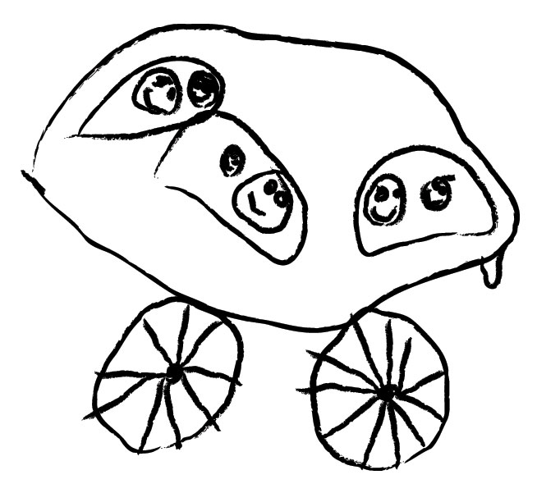

The Relationship Between Open Door School
and
Piedmont Progressive Preschool
The Open Door School, located at the Unitarian Universalist Church of Charlotte in the Cotswold neighborhood, was the inspiration for the Piedmont Progressive Preschool. It was the first open preschool in Charlotte; it was also the first integrated preschool in Charlotte. PPP's founders, Mary Coppola and Susan Burns, met when they were parents of children attending Open Door School and began carpooling because they lived across town from the school. They made the long drive because they felt the philosophy of the preschool was vital to their children's well-being and there was nothing like it in any other part of town. Sue Riley, founder of Open Door, suggested that they start a school in the University area, because another school similar to Open Door was needed in Charlotte. The rest is history! Though the two schools have no official relationship, Open Door School staff has been very helpful in nurturing the PPP –sharing supplies, paperwork, ideas, and good advice. We are grateful to them for their support, and we especially treasure the memory of the late Sue Riley who gave us the idea in the first place.

The Little Boy
by Helen E. Buckley
[Editor’s note: this will NOT happen to your child at Piedmont Progressive]
Once a little boy went to school. He was quite a little boy and it was quite a big school, but when the little boy found that he could go to his room by walking right in from the door outside he was happy and the school did not seem quite so big any more.
One morning, when the little boy had been in school a while, the teacher said, “Today we are going to make a picture.” “Good,” thought the little boy. He liked to make pictures...he could make all kinds—lions and tigers, chickens and cows, trains and boats, and he took out his box of crayons and began to draw. But the teacher said, “Wait...it’s not time to begin,” and she waited until everyone was ready. “Now,” said the teacher, “We are going to make flowers.” “Good,” thought the little boy, he liked flowers and he began to make beautiful ones with his pink and orange and blue crayons, but the teacher said, “Wait—and I will show you how.” And it was RED with a green stem. “There,” said the teacher, “Now you may begin.”
On another day when the little boy had opened the door from the outside all by himself, the teacher said, “Today we are going to make something with clay.” “Good,” thought the little boy...he could make all kinds of things with clay...snakes and snowmen, elephants and mice, cars and trucks, and he began to pull and pinch his ball of clay. But the teacher said, “Wait and I will show you how.” And she showed everyone how to make one deep dish. “There,” said the teacher, “Now you may begin.” The little boy looked at the teacher’s dish. Then he looked at his own. He liked his dishes better than the teacher’s, but he did not say this—he just rolled his clay into a big ball again and made a dish like the teacher’s. It was a deep dish.
And pretty soon the little boy learned to wait and to watch and to make things just like the teacher. And pretty soon he didn’t make things on his own any more. Then it happened that the little boy and his family moved to another house in another city and the little boy had to go to another school. This school was even bigger than the other one and there was no door from the outside into his room. He had to go up some big steps and walk down a long hall to get to his room. And the very first day he was there, the teacher said, “Today we are going to make a picture.” “Good” thought the little boy and he waited for the teacher to tell him what to do. But she didn’t say anything. She just walked around the room. When she came to the little boy, she asked, "Don’t you want to make a picture?” “Yes,” said the little boy. “What are we going to make?” “I don’t know until you make it.” said the teacher. “How shall I make it?” asked the little boy. “Why, any way you like,” said the teacher. “And what color?” asked the little boy. “Any color,” said the teacher. “If everyone made the same picture and used the same colors, how would I know who made what and which was which?” “I don’t know,” said the little boy. And he began to make a RED flower with a green stem.

Piedmont Progressive Preschool
2020-21 Handbook Acknowledgement
Dear Parent or Guardian,
All of the information in our handbook is intended to help families understand how our school functions. Some policies, however, stand out as critical to helping us all work together. Please sign and return this entire page, after you have read the 2014–2015 Piedmont Progressive Preschool Family Handbook.
Please return to Piedmont Progressive Preschool by January 30, 2021
Class(es): (please circle) Th/F 2/3s M-W 3/4s M-Th4/5s
Child(ren)’s Name(s):
(please print)
I have received a parent handbook, have read and understand its contents, and agree to abide by the following policies:
“Talking About Children in Their Presence,” page 6
Late Pickup Policy, page 16
Health Care Policies, page 18
Financial Arrangements, page 19
Grievance Procedure, page 20
Discipline & Classroom Management, page 20
Inclusion Policy,” page 21
______ Volunteer Policy, page 24
______ I understand that a parent needs to attend at least 3 Parent Education Events
Parent or Guardian A:
(please print)
Signature: Date:
Parent or Guardian B:
(please print)
Signature: Date:

Sue Spayth Riley, How to Generate Values in Young Children.
Pathways to Learning: An Early Childhood Resource and Curriculum Guide, self-published.
Katherine Reeves was professor of Child Development and Family Relationships, at Cornell University at the time this was printed in Growing, vol. 14, No. 2, January-March, 1962, pp 16-18.
This article, formerly “Helping that Doesn’t Help, but Hinders,” is a revised version of a letter written by an Open Door teacher to the parents of her class, edited by Sue Riley.
While we at Piedmont Progressive do not celebrate the holidays in the classrooms, the church’s Religious Education (RE) program sponsors holiday activities in which Piedmont Progressive families are welcome to participate.
Much of the information on the centers is excerpted or adapted from Pathways to Learning: An Early Childhood Resources and Curriculum Guide.
To make play dough at home, mix 1 cup white flour, ¼ cup salt, 2 teaspoon cream of tarter, 1 cup water, 1 tablespoon vegetable oil in a saucepan over low heat. Dough is ready when it rolls into a ball. Keep dough fresh in an airtight container. If you want to make different colors, add food coloring while mixing over heat. Microwave method: Mix one 16 oz box of baking soda and 1 cup corn starch, and add 1¼ cup water, mixing until smooth. Microwave 4–8 minutes, stirring after each minute. Stop when dough is stiff but still stirrable. Cover with damp cloth to cool
Special needs children refers to children with physical disabilities, psychological illnesses or genetic disorders (such as Downs Syndrome).

